Subject 2 – MLP vs. Linear Regression vs. State Space model

Elbow flexion/extension – no crossvalidation -MLP

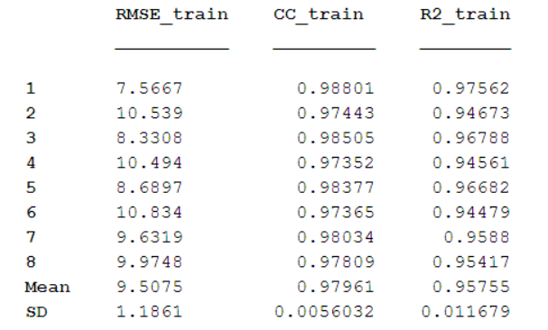

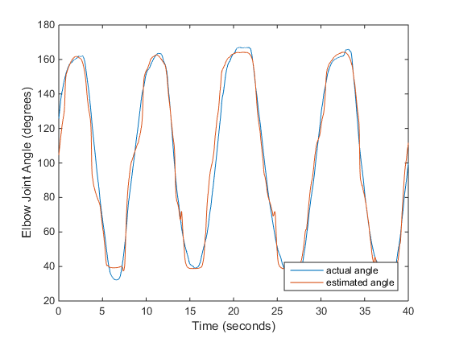

Figure 1 - Trial 1 no CV

Elbow flexion/extension – with cross-validation

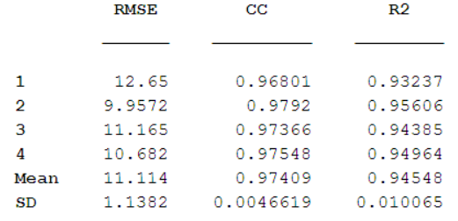

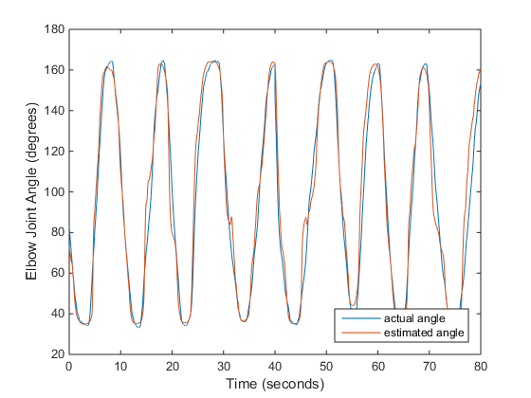

Figure 2 - Fold 2 - with CV

Linear Regression – No CV

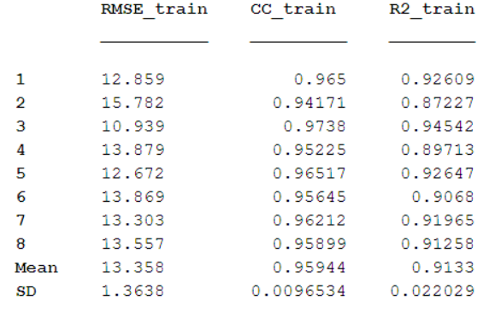

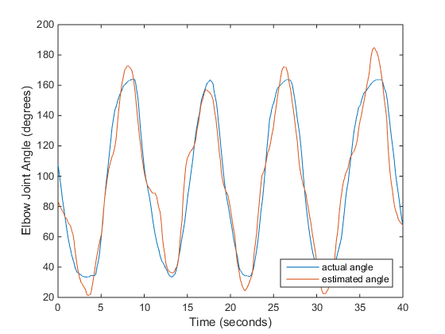

Figure 3 - Trial 5 – noCV – Linear Regression

Linear Regression with crossvalidation

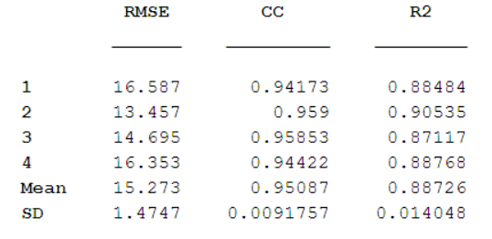

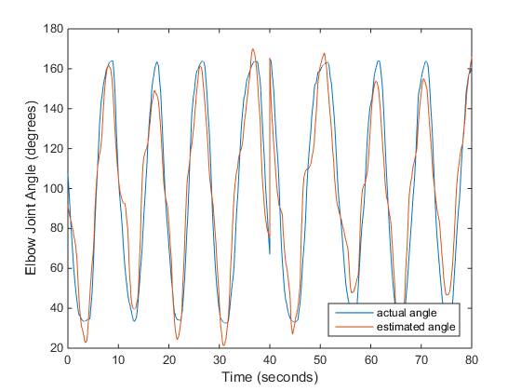

Figure 4 - Fold 3 - with CV – LR

State Space Model – no crossvalidation